# Lab: Routing

Lab problem for the [“JavaScript Applications” course @ SoftUni](https://softuni.bg/courses/javascript-applications).

## Initial Setup

Explore the provided **skeleton**. Install **dependencies** in both projects and run them. Use [Postman](https://www.getpostman.com/) to **test** signing up and signing in Kinvey.

## Implement Furniture Store

In the app, you should have the following URL's:

* Create Furniture (POST): **/furniture/create**
* All Furniture (GET): **/furniture/all**
* Furniture Details (GET): **/furniture/details/{id}**
* My Furniture (GET): **/furniture/mine**
* Delete Furniture (DELETE): **/furniture/delete/{id}**

### Create Furniture

**HTML template:**

|  |
| --- |
| <div class="container">  <div class="row space-top">  <div class="col-md-12">  <h1>Create New Furniture</h1>  <p>Please fill all fields.</p>  </div>  </div>  <form>  <div class="row space-top">  <div class="col-md-4">  <div class="form-group">  <label class="form-control-label" for="new-make">Make</label>  <input class="form-control" id="new-make" type="text">  </div>  <div class="form-group has-success">  <label class="form-control-label" for="new-model">Model</label>  <input class="form-control is-valid" id="new-model" type="text">  <div class="form-control-feedback">This input value is valid</div>  </div>  <div class="form-group has-danger">  <label class="form-control-label" for="new-year">Year</label>  <input class="form-control is-invalid" id="new-year" type="number">  <div class="form-control-feedback">This input value is invalid</div>  </div>  <div class="form-group">  <label class="form-control-label" for="new-description">Description</label>  <input class="form-control" id="new-description" type="text">  </div>  </div>  <div class="col-md-4">  <div class="form-group">  <label class="form-control-label" for="new-price">Price</label>  <input class="form-control" id="new-price" type="number">  </div>  <div class="form-group">  <label class="form-control-label" for="new-image">Image</label>  <input class="form-control" id="new-image" type="text">  </div>  <div class="form-group">  <label class="form-control-label" for="new-material">Material (optional)</label>  <input class="form-control" id="new-material" type="text">  </div>  <input type="submit" class="btn btn-primary" value="Create" />  </div>  </div>  </form>  </div> |

**Validate fields:**

* Make and Model must be at least **4 symbols** long
* Year must be between **1950** and **2050**
* Description must be **more** than **10 symbols**
* Price must be a **positive number**
* Image URL is **required**
* Material is **optional**

If the creation is **successful** show a **message** and **redirect** to all furniture.

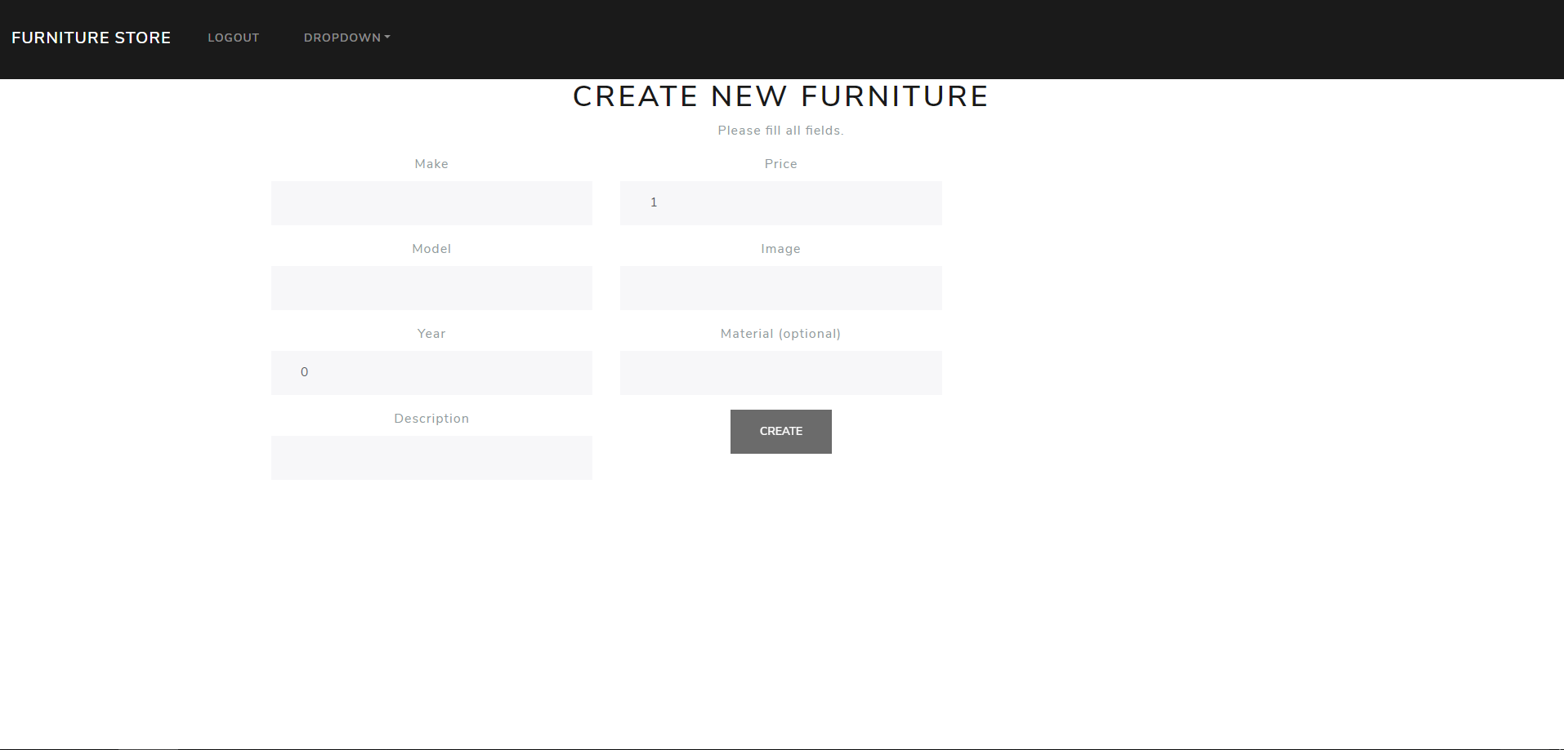

### All Furniture

**HTML template:**

|  |
| --- |
| <div class="container">  <div class="row space-top">  <div class="col-md-12">  <h1>Welcome to Furniture System</h1>  <p>Select furniture from the catalog to view details.</p>  </div>  </div>  <div class="row space-top">  <div class="col-md-4">  <div class="card text-white bg-primary">  <div class="card-body">  <blockquote class="card-blockquote">  <img src="imageUrl" />  <p>Description here</p>  <footer>Someone famous in  <cite title="Source Title">Source Title</cite>  </footer>  <div class="pull-right">  <a href=”#” class="btn btn-info">Details</a>  </div>  </blockquote>  </div>  </div>  </div>  </div>  </div> |

**List all furniture** inside the store.

Create a router link to **redirect to details**.

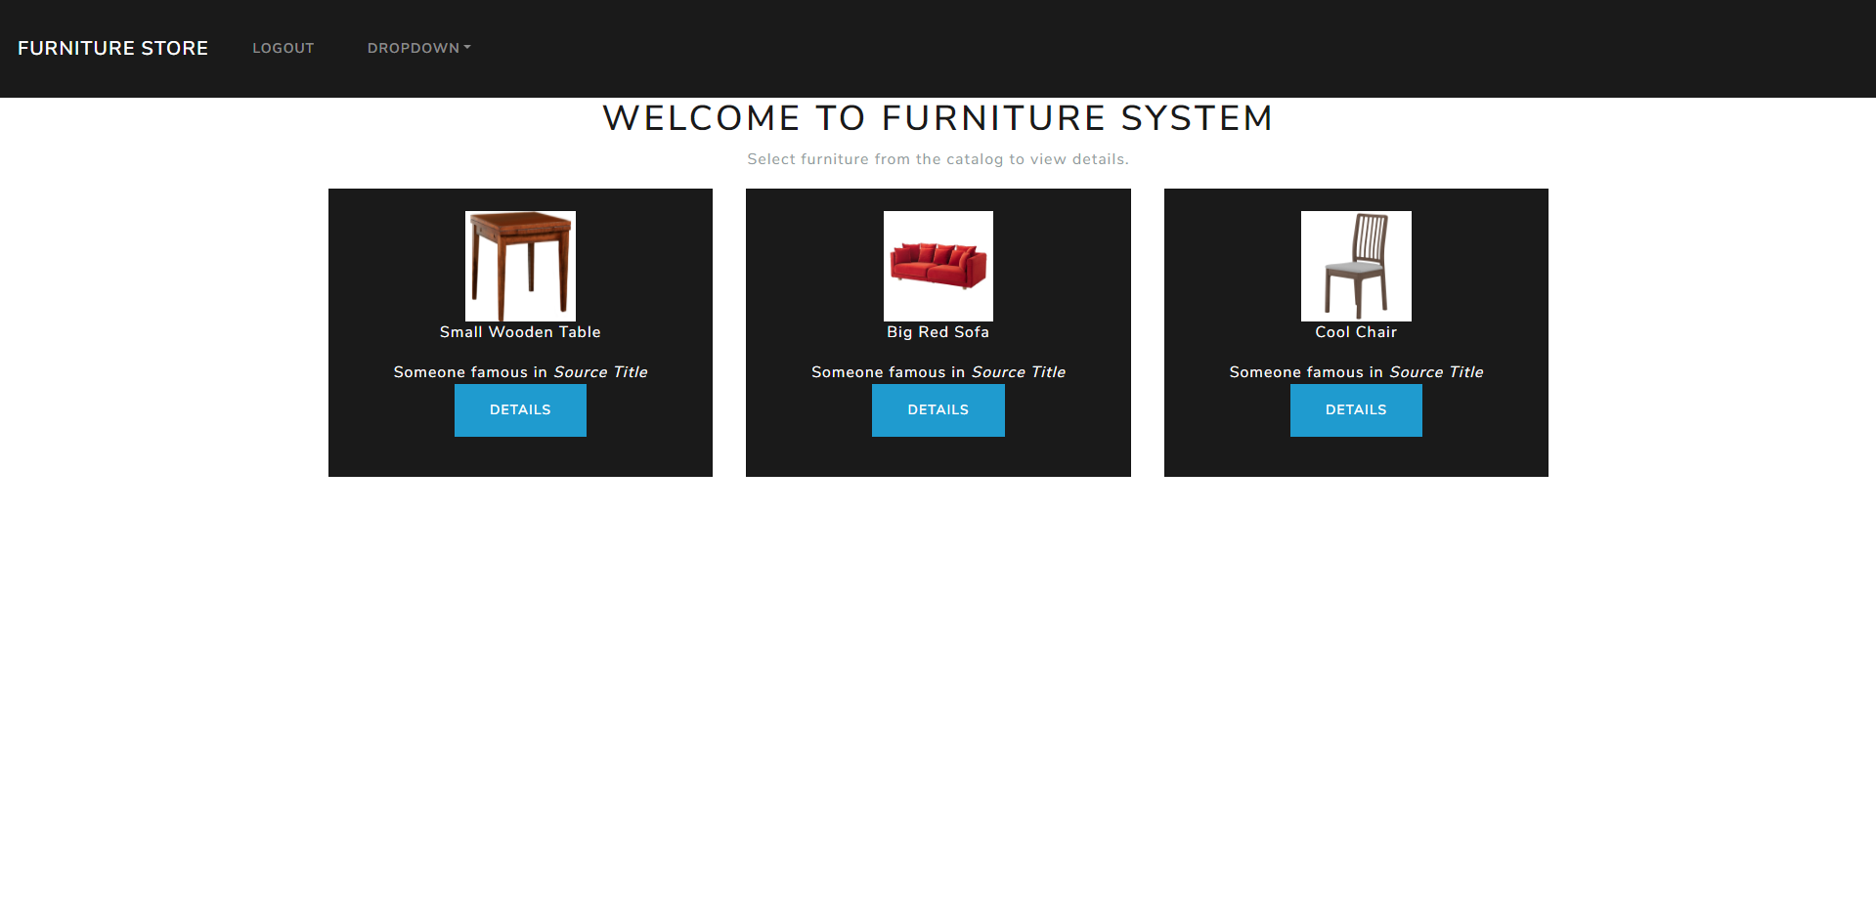

### Furniture Details

**HTML template:**

|  |
| --- |
| <div class="container">  <div class="row space-top">  <div class="col-md-12">  <h1>Furniture Details</h1>  </div>  </div>  <div class="row space-top">  <div class="col-md-4">  <div class="card text-white bg-primary">  <div class="card-body">  <blockquote class="card-blockquote">  <img src="imageUrl" />  </blockquote>  </div>  </div>  </div>  <div class="col-md-4">  <p>Make: make</p>  <p>Model: model</p>  <p>Year: year</p>  <p>Description: description</p>  <p>Price: price</p>  <p>Material: material</p>  </div>  </div>  </div> |

Get the **id** from the **URL** and **display** the information.

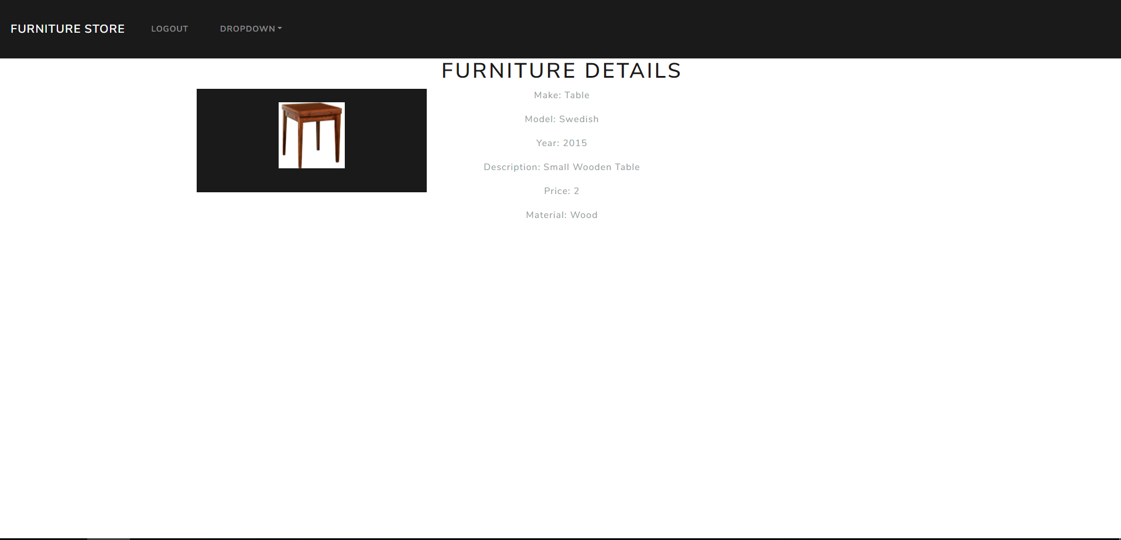

### My Furniture

**HTML template:**

|  |
| --- |
| <div class="container">  <div class="row space-top">  <div class="col-md-12">  <h1>Profile Page</h1>  <p>Listing your furniture.</p>  </div>  </div>  <div class="row space-top">  <div class="col-md-4">  <div class="card text-white bg-primary">  <div class="card-body">  <blockquote class="card-blockquote">  <img src="imageUrl" />  <p>Description Here</p>  <footer>Someone famous in  <cite title="Source Title">Source Title</cite>  </footer>  <div class="pull-right">  <a href=”#” class="btn btn-info">Details</a>  <a href=”#” class="btn btn-danger">Delete Item</a>  </div>  </blockquote>  </div>  </div>  </div>  </div> |

List all **user created** furniture, link to **redirect** to details and ability to **delete** your own items.